|  |
| --- |
| **HOTEL MANAGEMENT SYSTEM** |
|  |
|  |
|  |
|  |
|  |
|  |
|  |

#### VISVESVARAYA TECHNOLOGICAL UNIVERSITY

***BALAGVI***



##### A Project Report

*On*

*HOTEL MANAGEMENT SYSTEM*

*Submitted in Partial fulfillment of requirement for the*

***SOFTWARE ENGINEERING (****17CS42****)***

*in*

***Computer Science & Engineering*** *By*

*NIVEDITHA G 3VC17CS060*

***Faculty In-Charge***

***Mr. Suresh Associate Professor CSE Department, RYMEC***

***Mr. B. Veeresh Gouda Assistant Professor CSEDepartment,RYMEC***



DEPARTMENT OF COMPUTER SCIENCE & ENGINEERING ACCREDITED BY NATIONAL BOARD OF ACCREDITATION

RAO BAHADUR Y MAHABALESHWARAPPA ENGINEERING COLLEGE CANTONMENT, BALLARI-583104, KARNATAKA

***2019 – 2020***

***VEERASHAIVA VIDYAVARDAHKA SANGHA’S***

## RAO BAHADUR Y MAHABALESHWARAPPA ENGINEERING COLLEGE

(AFFILIATED TO VISVESVARAYA TECHNOLOGICAL UNIVERSITY, BELGAUM & APPROVED BY AICTE, NEWDELHI)

BALLARI – 583104, KARNATAKA

#### DEPARTMENT OF COMPUTER SCIENCE & ENGINEERING

***ACCREDITED BY NATIONAL BOARD OF ACCREDITATION***



*CERTIFICATE*

*This is to certify that project work entitled* ***“****HOTEL MANAGEMENT SYSTEM****”*** *is a bonafied Work carried out by* ***NIVEDITHA G (3VC17CS060)*** *of 4thSemester in Partial fulfillment of requirement for* ***SOFTWARE ENGINEERING (****17CS42****)*** *during the year* ***2019-2020.***

#### Signature of Staff -Incharge Signature of HOD

##### Mr. Suresh Dr T.Hanumantha Reddy

*Assosiate Professor , HOD,Dept of CSE,*

*Dept of CSE, RYMEC . RYMEC.*

1. *Mr. B Veeresh Assistant Professor, Dept of CSE, RYMEC.*

## Name of Examiners: Signature with Date

*ACKNOWLEDGEMENT*

I have taken efforts in this project. However, it would not have been possible without the kind support and help of many individuals and organizations. I would like to extend my sincere thanks to all of them.

I am highly indebted Mr.Suresh and Mr.B.Veeresh Gouda for their guidance and constant supervision as well as for providing necessary information regarding the project & also for their support in completing the project.

*I would like to express my gratitude towards the member of RAO BAHADUR Y MAHABALESHWARAPPA ENGINEERING COLLEGE for their kind co-operation and encouragement which help me in completion of this report.*

My thanks and appreciations also go to my friends in developing the project and people who have willingly helped me out with their abilities.

CONTENTS:

1. INTRODUCTION
   1. PURPOSE
   2. SCOPE OF PROJECT
2. INTENDED AUDIENCE
3. OBVERALL DESCRIPTION
   1. START WITH PURPOSE
   2. FUNCTIONAL REQUIREMENTS
4. SYSTEM FEATURES
   1. CLASSIFICATION
   2. PAYMENT
5. EMPLOYEE DETAILS
   1. OWNER
   2. MANAGER
   3. RECEPTIONIST
6. NON-FUNCTIONAL REQUIREMENTS
   1. SAFETY REQUIREMENTS
   2. SECURITY REQUIREMENTS
   3. OTHER REQUIREMENTS
7. USE-CASE DIAGRAM
8. DATA – FLOW DIAGRAM
9. OVERVIEW
   1. USER NEEDS
   2. ASSUMPTIONS AND DEPENDENCIES

1. INTRODUCTION:

This is the report document for development Hotel Management System for HOTEL. It consists of the development of finalized Hotel Management System. Fully functional Hotel Management System will fulfill the main objectives and all the events of the Hotel.

* 1. PURPOSE:

The SRS will provide a detailed description of the requirements for the Hotel Management System (HMS). The clear understanding of the system and its functionality will allow for the correct software to be developed for the end user and will be used for the development of the future stages of the project. This SRS will provide the foundation for the project.

1.2 SCOPE OF PROJECT:

The introducing software, Hotel Management System which is going to be implemented for Hotel will automate the major operations of the hotel. The Reservations System is to keep track in room and hall reservation and check availability. The Room Management System is for managing all room type services. The Inventory Control System will help keep track in all inventories of the hotel and guest details will be handled by guest management. Administration department will monitor the all.

1. INTENDED AUDIENCE:

🡪The intended audience of this document would be owner and specific employees like manager and receptionist of hotel and project team with objective to refer and analyze the information. The SRS document can be used incase regarding the requirements of the project.

3 OVERALL DESCRIPTION:

🡪The Hotel Management System is a new self-contained software product which will be product by the project team in order to overcome the product by the project team in order to overcome the problems that have occurred due to current manual system.

🡪The newly introduced system will provide an easy access to the system and it will contain user friendly functions with attractive interface.

3.1 START WITH PURPOSE:

🡪 The SRS will provide a detailed description of the requirements for the HMS. SRS will allow for a complete understanding of what is to expected from the newly introduced system which is to be constructed.

🡪 Clear understanding of the system and its functionality will allow for the correct software to be developed for the end user.

3.2 FUNCTIONAL REQUIREMENTS:

🡪 Make Reservations

🡪 Search Rooms

🡪 Add Payment

🡪 Issue Bills

🡪 Manage Guest

🡪 Manage Room Details

🡪 Manage Staff

🡪 Manage Users

🡪 Taking Backups , Email Notifications etc.

1. SYSTEM FEATURES:

RESERVATION:

🡪It is easier to check-in and check-out of the hotels because of the software giving a quick guide to the room availability and other details related to changes.

* 1. CLASSIFICATION:

🡪The classification of HMS deals with the elaboration of its features. The HMS may be classified into: Accomodation , Function-Hall, Restaurant, Staff etc.

🡪The Accommodation is the availability of rooms. The rooms have two types called A/C and non-A/C, where A/C rooms have types with Single, Double and Suite but non-A/C rooms has only two i.e. Single and Double.

🡪The Function-Hall is the private hall booked by the customer for social, family events or official meetings.

🡪Restaurant is owned by the hotels itself , they provide private space for customers regarding their tastes and needs like veg, non-veg foods and bars.

🡪Staff or Employee are the important peoples who work for the hotel like Manager , Receptionist, Clerks, Chefs etc.

CLASSIFICATION-DIAGRAM:

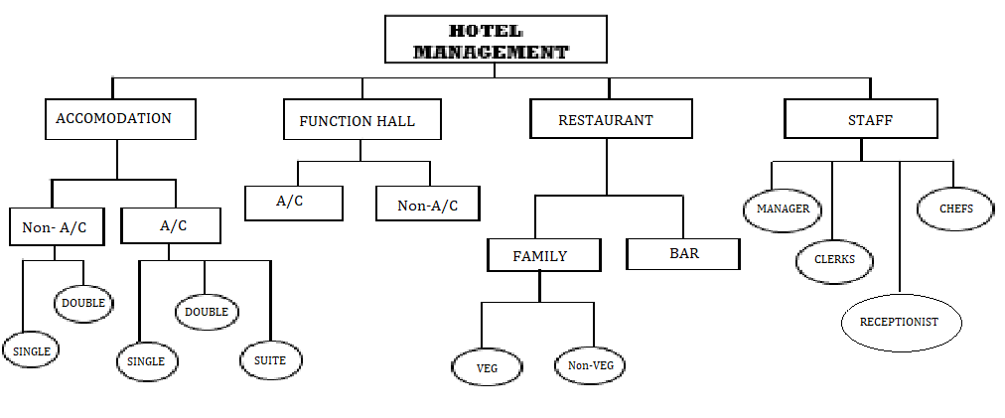

4.2 PAYMENT(BILLING):

🡪HMS helps the manager or admin to accept payment of the customer via credit cards/debit cards.

🡪It is automatically updated to their financial data base & also to the guest information.

1. EMPLOYEE DETAILS:

🡪The manager or admin can assign duties according to the list of employee’s. They can interchange the duties when required and even get the contract details.

* 1. OWNER:

🡪Owner of the hotel can monitor and authorize the task handed by the system. Owner and system can access to the admin panel which is considered as the core of the system.

🡪Owner can manage the other users including their user levels and privileges.

* 1. MANAGER:

🡪Manager is responsible for managing resources available in HMS. Manager has most of the privileges except the things regarding payment handling.

🡪The reason of using manager is to reduce the work load of the owner that cannot be assigned to receptionist.

* 1. RECEPTIONIST:

🡪As a Hotel Receptionist, his or her role will be to obtain the goals of bookings & to ensure that all guests are treated with a high standard of customer services.

🡪They perform limited functions such as registering the guest to the system, make reservations, sending e-mail remainders for booking confirmations.

1. NON-FUNCTIONAL REQUIREMENTS:

6.1 SAFETY REQUIREMENTS:

🡪There are several user levels in HMS, access to the various subsystems will be protected by a user login screen that requires user name and password.

🡪Maintaining backups ensure the system database security. System can be restoring in any case of emergency.

6.2 SECURITY REQUIREMENTS:

🡪Customer services representatives , managers and owner will be able to login to HMS. Owner has maximum privilege to all subsystems.

6.3 OTHER REQUIREMENTS:

🡪Few sessions will be required to make the users to understand about the functionality of the system and some to adapt to it.

🡪After the sessions, it’s required that a member from the development team should spend sometime in the system background for an agreed time period.

🡪This time is used to identify the new bugs that could not be reached in the earlier phases of development process.

7 USE-CASE DIAGRAM:

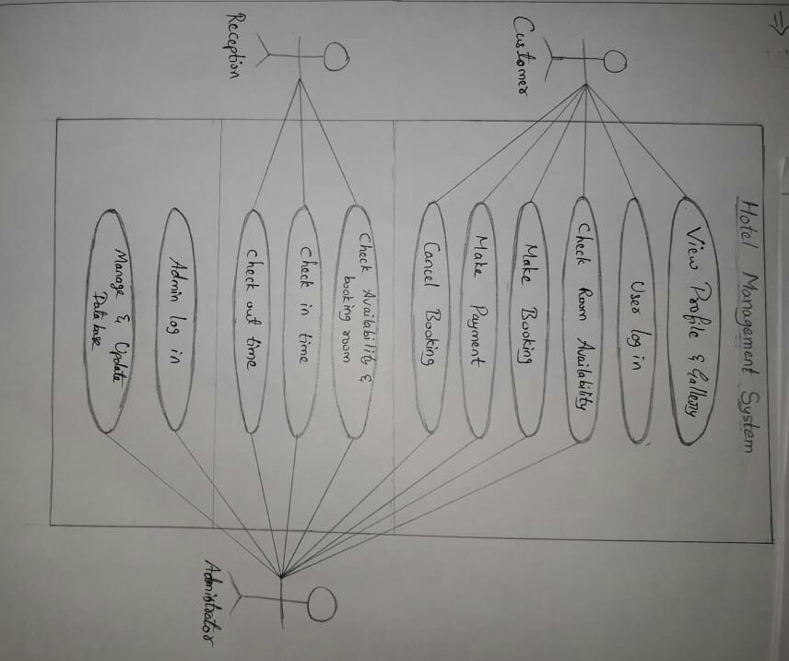

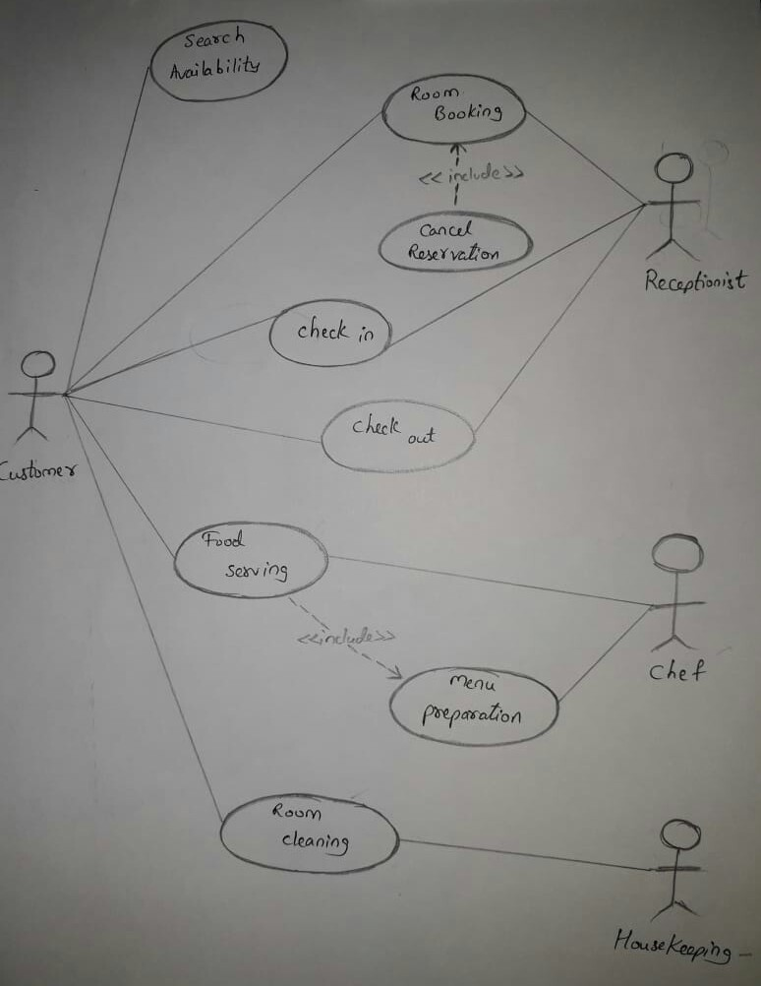

🡪The Use-case diagram for HMS is used o link the functionalities among the hotel staffs with the customer.

🡪View Profile & Gallery: Customer can see the profile of the hotel system and also environment of the hotel through the pictures online.

🡪User Login: As the customer is logged in, they are directed for checking the room availability. User login is for safety purpose where the customer have their own password to login.

🡪Customer can make the booking & payment directly or through online. It can also be cancelled.

🡪The Receptionist usually interact with customer & manage details of customer. Admin usually go through all the process going on in the system.

1. DATA-FLOW DIAGRAM:

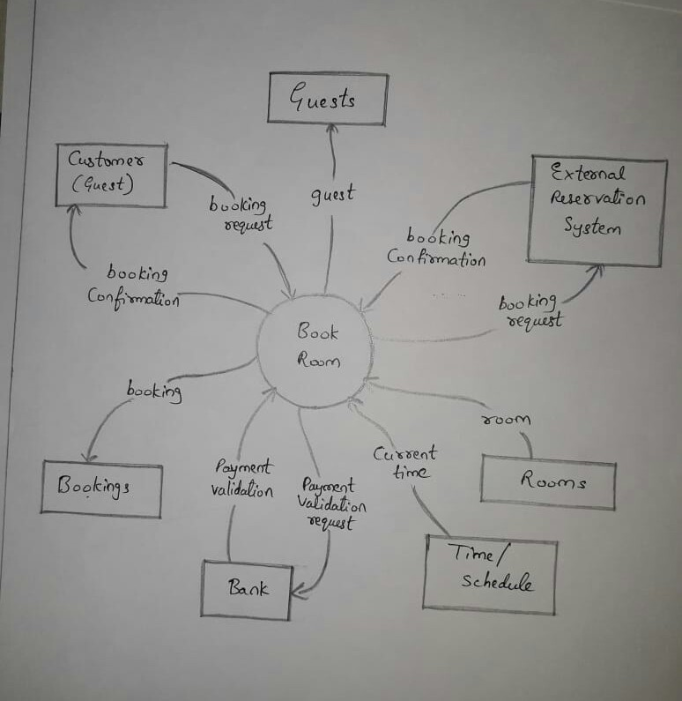

9 OVERVIEW:

9.1 USER NEEDS :

Main aim is to satisfy the customer basic requirements. The requirements may include:

🡪Room Availability

🡪Cancellation of Rooms

🡪Room Services

🡪Laundry

🡪Cab Services

🡪Trip Plan

🡪Functional Halls

🡪Event Organizing Platform

🡪Discounts

🡪Lodging

🡪Restaurant

🡪Spa’s

🡪Online Home Delivery

🡪Tickets Booking for Customer

* 1. ASSUMPTIONS & DEPENDENCIES:

🡪Some software used in implementing the system is with high cost & the client has agreed to afford the amount of money needed to purchase them.

🡪It’s assumed that the client won’t change his decision on the next phases of the software development.

🡪Although we assume that client is using windows Operations System Otherwise if client use an open source operating system, there is a need of changing the SRS accordingly.